|  |
| --- |
| THE FUTURE OF TOURISM IN SCOTLAND  2020 |
|  |
| aUGUST 2020  IBM Applied Data Science Capstone  Authored by: Abbey MacFarlane |

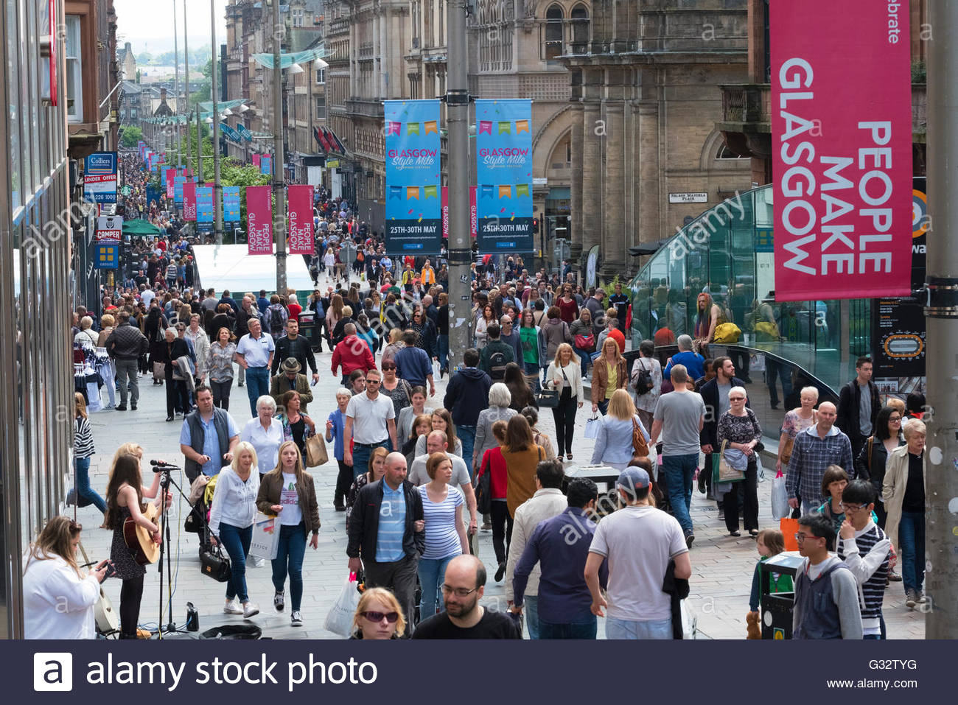



# Introduction

|  |
| --- |
| Every year, millions of tourists flock to Scotland, UK for many different reasons including city breaks, road trips and tracing ancestral routes.  As there is such a wide variety of attractions to the small country, it would be advantageous for the travel & tourism industry to know exactly where in Scotland they should be advertising based on the preferences of their target demographic.  In this presentation, we will analyze existing data from Foursquare, Wikipedia and the Scottish government website to show where might be the most profitable location for tourists in Scotland based on individual preferences to aid in a marketing campaign. |

# BUSINESS PROBLEM

|  |
| --- |
| A travel company are wanting to launch a marketing campaign for holidaying in Scotland. Since the attractions of Scotland are so diverse, they want to make sure that they can target the right audience, through the right channels, with the right destination to maximize their profits. |

# TARGET AUDIENCE

|  |
| --- |
| Airlines, package holiday companies and other travel and tourism businesses. |

# METHODOLOGY

|  |
| --- |
| The analysis was carried out using python and python libraries including pandas, *matplotlib* & *geopy*, using a notebook on IBM Cloud.  First, We used the data for expenditure and visits to Scotland 2013-2019 to create line graphs using the *matplotlib* library to show which Location type was most popular and had the highest expenditure.  I then plotted a scatter graph also with *matplotlib* to determine the correlation between Expenditure and Visits.  As it was established that City/large town was the most profitable type of holiday to Scotland, we preceded to use the *BeautifulSoup* package to web-scrape a Wikipedia page and turn it into a pandas data frame that listed Scottish towns and cities by population.  From this analysis it was clear that Glasgow and Edinburgh were the two largest cities in Scotland and therefore narrowed down the focus of my analysis to these cities only.  I then used the *Nominatim* function of *geopy* to get the coordinates of the cities to use for further analysis.      I then leveraged the Foursquare API to find out how many of a particular venue each city had. The same radius was used for both cities on each search to produce an accurate comparison.  Firstly the search was for “museum” for both Glasgow and Edinburgh and put the findings into a pie chart for visualization.  Secondly, we searched “soccer stadiums” and again plotted this on a pie chart.  Lastly, we searched “nightclub” and used a final pie chart to show my findings. RESULTS From the first graphs produced from the Expenditure/Visits data we can clearly see that City/large town was the most popular and profitable holiday choice in Scotland, followed by Rural Countryside.  We could also see a dip in Expenditure in 2015.      From the scatter graph we can see there is a strong, positive linear correlation between expenditure and visits which would be expected.    The population data scraped from Wikipedia showed that Glasgow was the largest city in Scotland by population, followed by Edinburgh, Aberdeen and then Dundee.    The data retrieved from the Foursquare API showed that for venues related to “museum” within a radius of 1000, Glasgow had 4 whereas Edinburgh had 30 which accounted for 86.2%.    When searching for “soccer stadium” within a radius of 10,000, we could see that both Glasgow and Edinburgh had 4 stadiums, resulting in a 50/50 split.    On the last search for “nightclub” within a radius of 500, Edinburgh only had 7 compared to Glasgow’s 8. This gives Glasgow a slightly higher percentage of 53.3%. |

# DISCUSSION

|  |
| --- |
| Aside from the aforementioned analysis, there was another noticeable anomaly where we can see a significant dip in expenditure from 2014 to 2015. A Google search of "Scotland 2014" shows at the end of 2014, Scotland held a referendum on independence. This referendum appears to have had a negative impact on tourist spending within Scotland, as reports elsewhere on the web show that there was a 4.4% rise in tourism globally in 2015. (source <https://www.theguardian.com/travel/2016/jan/19/tourism-worldwide-reaches-record-levels-in-2015-in-defiance-of-terrorism-threat> )  It is also public knowledge that Glasgow held the 2014 Commonwealth Olympics which may have disproportionately heightened the figures in our data for 2014.  From this report, we would recommend that a marketing campaign is best launched for city breaks in Scotland. Specifically Edinburgh for museum enthusiasts and Glasgow for the nightlife. |

# CONCLUSION

|  |
| --- |
| This report therefore concludes that tourists coming to Scotland are more likely to choose a city break than any other type of holiday.    This report also concludes that:  If your target audience prefer museums, then Edinburgh is the best Scottish location to market as a holiday destination.  If your target audience are interested in football, they are equally as likely to enjoy Glasgow or Edinburgh.  If your target audience prefer nightclubs, then they are slightly more likely to prefer Glasgow and prefer this as a holiday destination.  These findings give merit to the well-known Scottish saying: |
| *"Edinburgh is the pretty lassie in the nightclub, but Glesga is the wan that'll show ye a good time"*  *~ Scottish Proverb* |